PCAN

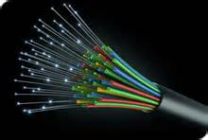

CONNECTING PLATTEVILLE

**P**latteville **C**ommunity **A**rea **N**etwork

C:\Documents and Settings\leightyj\Local Settings\Temporary Internet Files\Content.IE5\MDANU5O1\MC900318996[1].wmfC:\Documents and Settings\leightyj\Local Settings\Temporary Internet Files\Content.IE5\MDANU5O1\MC900318996[1].wmfC:\Documents and Settings\leightyj\Local Settings\Temporary Internet Files\Content.IE5\MDANU5O1\MC900318996[1].wmfC:\Documents and Settings\leightyj\Local Settings\Temporary Internet Files\Content.IE5\MDANU5O1\MC900318996[1].wmf

P C A N

PLATTEVILLE COMMUNITY AREA NETWORK

JOINING PLATTEVILLE TOGETHER